ELL409   
Assignment 1

Vansh Gupta  
2019EE10143

**Part 1A**

* Using only 20 data points

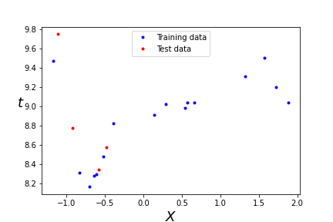  
Fig 1. Randomly sampled 20 data points

* Using Moore-Penrose pseudoinverse:

I run my code for different values of (regularization constant) and epochs (number of iterations). [Fig 2.]

After that, I observed that the number of epochs have no effect on the losses, which is also expected since our dataset is very small for the model to have to learn the same data point again. Moreover, this method is not exactly learning but presenting with a solution. Thus, I iterate over different . We can also see that while the training error has an elbow point at m=5 (m is the highest degree of polynomial), the test set is truly reduced for m=9. Thus, for further iterations, I will fix m at 9. [Fig 3]

Now, we see that that there is not much change for a range of values for . Even a value of 0 seems to be working fine suggesting that there is no overfitting that needs to be mitigated. This is possibly because with only 16 training points, it is like data is missing at lots of places, and since there is also noise in our data, the model is unable to exactly learn the curve or even overfit it.

A final plot for = 0, number of epochs = 1, over different values of m is shown in Fig. 4

Therefore, the best guess of the polynomial, for m = 9 and = 0 is:

8.99654324 0.32089103 0.30898259**2** 4.58312801**3** 3.91859305 6.12614492**5** 7.53175079**6** 0.885168573.20999694**8** 0.88288049

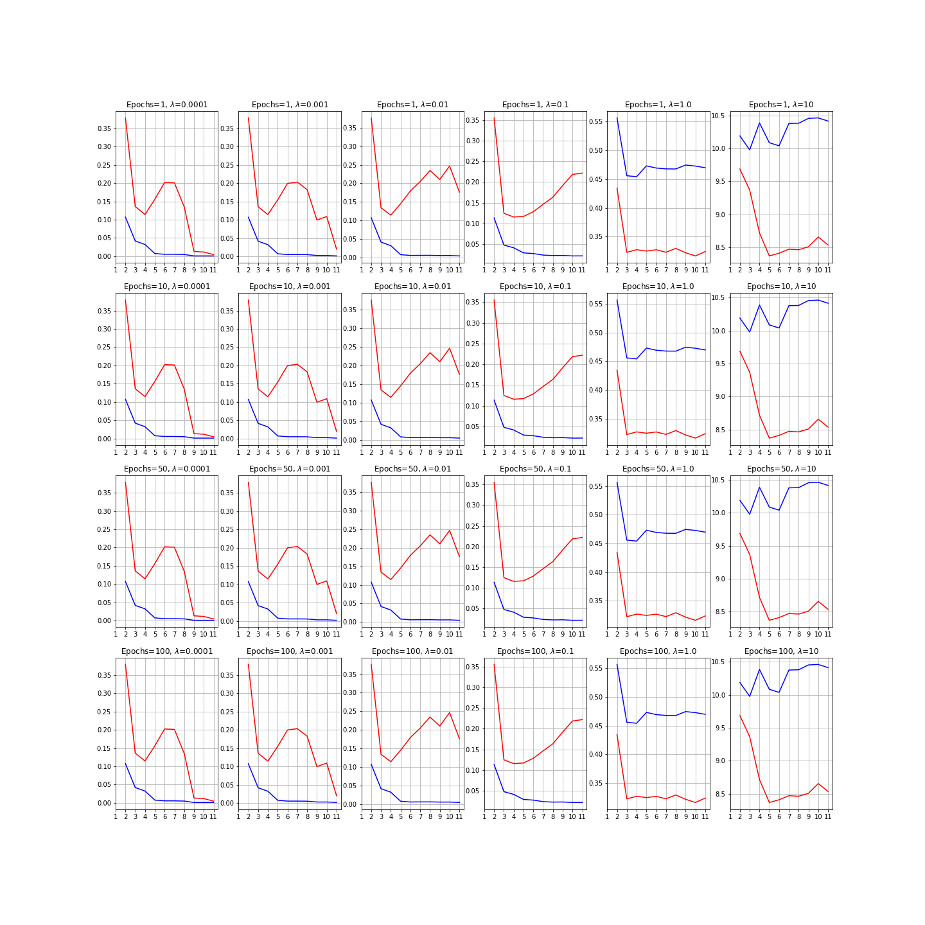  
Fig 2. The red line depicts the test error and the blue line shows the training error

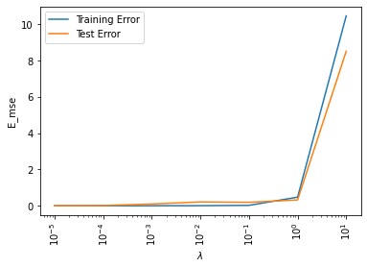  
Fig 3.

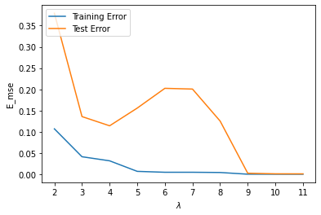  
Fig 4.

M

* Using Gradient Descent:

I followed the exact same procedure as listed for the Moore-Penrose pseudoinverse.

The inference for was absolute and not related to the method, therefore for this set of experiments, I keep to be 0. I also keep my epochs i.e., the number of iterations to be at a fixed value of 1500. This is because the data is small, and for gradient descent which does not produce a closed form solution, needs to go over the data multiple times to not succumb to underfitting

Thus, here my main focus is on the maximum degree of the polynomial (which should be the same), the learning rate and the size of our mini-batch.

First, for the learning rate, after trying various different values for , I came to the conclusion that there is no single good value for the learning rate and that it needs to change with time. Thus, once again after extensive experimentation, I found the value of to work best for the given data. Here, “” is the starting index for a certain mini-batch.

For the order of polynomial, I take number of epochs and learning rate value as described above and do mini-batch gradient descent on it for a batch size of 10. The results are in Fig. 5.

Note: For all models of gradient descent, I have used a min-max normalization followed by subtracting each dimension by its mean for faster and better convergence. The same normalizing parameters (Minimum, maximum, mean of min-max normalized training set) is used to normalize the test set

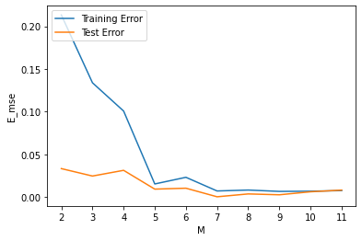   
Fig. 6: Blue line is training error while the orange line is test error

This is not something very good, but keeping in mind that there are only 20 data points, we will have to work with it. Highest degree 7 seems good enough for our gradient descent model.

Using 7 as our M, we know vary batch size from 1 to 16 (Size of training set)

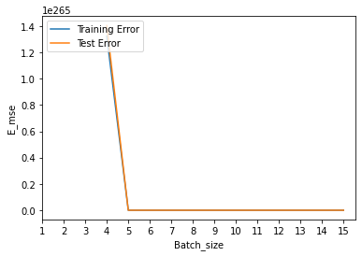  
Fig 6. The error for batch size < 4 was out of bounds. Nonetheless, it converges

Therefore, our initial batch size value of 10 was good for our final estimate of the polynomial which is:

8.88472159 0.8518583 1.09412644**2** 0.62121061**3** 2.52004379 0.22660583**5** 0.22836758**6** 2.82967896

* Using all 100 data points:

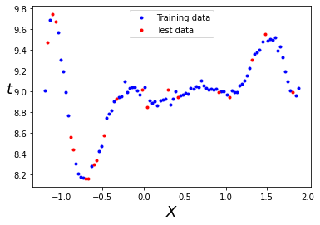  
Fig. 7

* Using Moore-Penrose pseudoinverse:

I run my code for different values of (regularization constant) and epochs (number of iterations). [Fig 8.]

Once again, we observed that the number of epochs have no effect on the losses. Thus, I iterate over different . We can also see that while the training error has an elbow point at m=5 (m is the highest degree of polynomial), the test set is truly reduced for m=9. Thus, for further iterations, I will fix m at 9. [Fig 9]

This time, we see that since number of data points is 100, there is some improvement with regularization at = 0.01 after which it starts under-fitting.

A final plot for = 0.01, number of epochs = 1, over different values of m is shown in Fig. 10 which confirms m= 9 to be a good basis.

Therefore, the best guess of the polynomial, for m = 9 and = 0.01 is:

9.0140234 0.01824327 0.97251592**2** 2.73209287**3** 1.05359651 4.21682231**5** 4.04789536**6** 0.86240564 1.9421145**8** 0. 51181432

Finally, Fig 10 shows this polynomial on data-points from the dataset

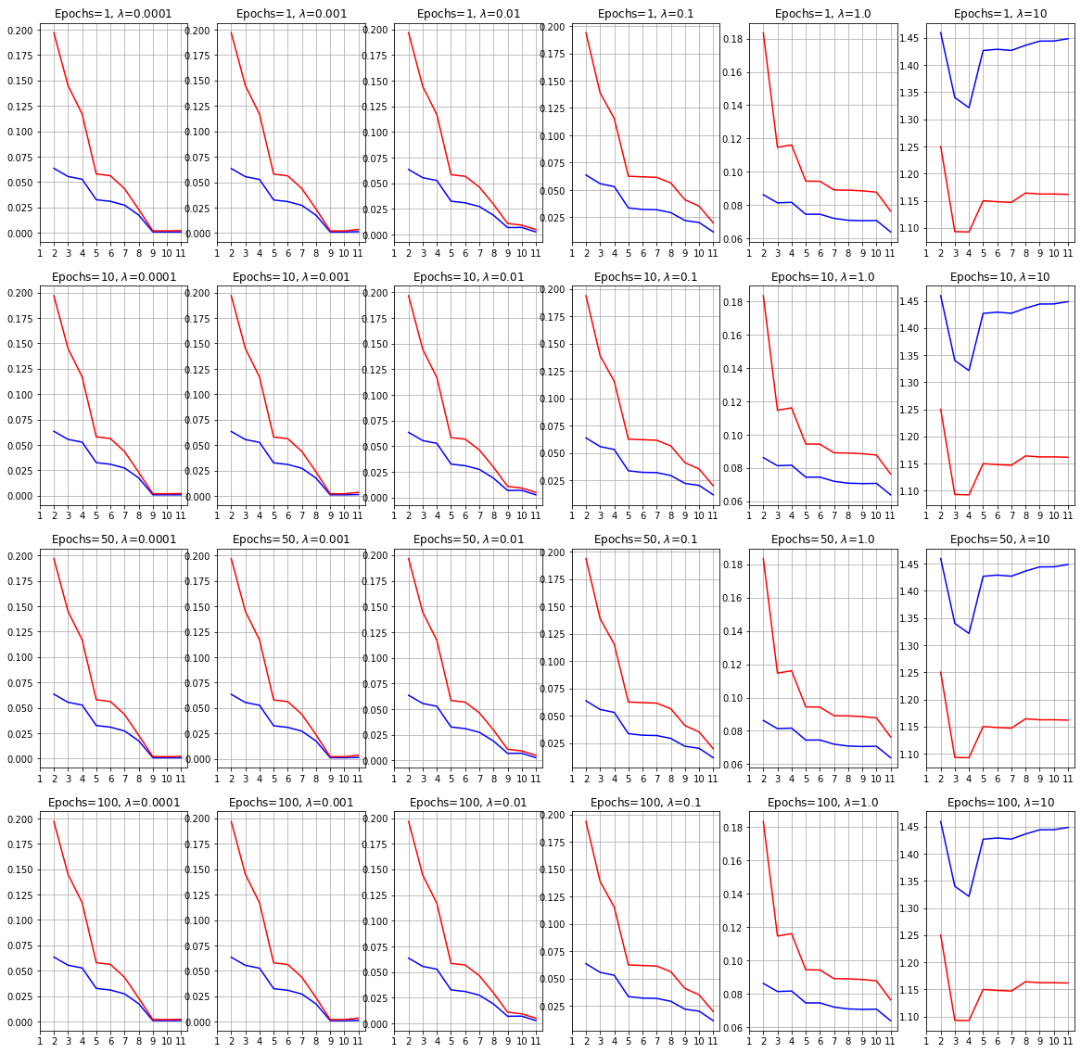  
Fig 8. The red line depicts the test error and the blue line shows the training error  
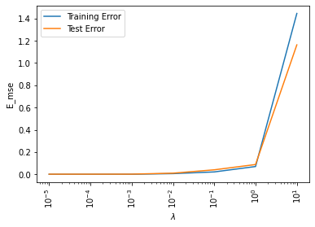  
Fig. 9

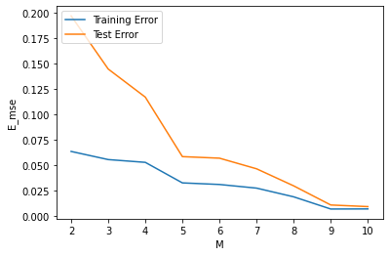

Fig 10.

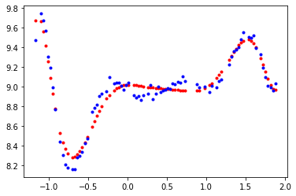  
Fig 11. Red dots showed the predicted target labels and blue dots are from the dataset

* Using Gradient Descent:

I followed the exact same procedure as listed for the 20 data points. However, I will need to check for appropriate value of as well.

First, for the learning rate, after trying various different values for , I came to the conclusion that there is no single good value for the learning rate and that it needs to change with time. Thus, once again after extensive experimentation, I found the value of to work best for the given data. Here, “” is the starting index for a certain mini-batch.

For the order of polynomial, I take number of epochs and lambda, and do mini-batch gradient descent on it for a batch size of 25. The results are in Fig. 12.

From Fig 12, we infer that the gradient descent seems to approximate the model to its best at M=5. Also, the model seems to perform well for and epochs = 1500

Note: For all models of gradient descent, I have used a min-max normalization followed by subtracting each dimension by its mean for faster and better convergence. The same normalizing parameters (Minimum, maximum, mean of min-max normalized training set) is used to normalize the test set

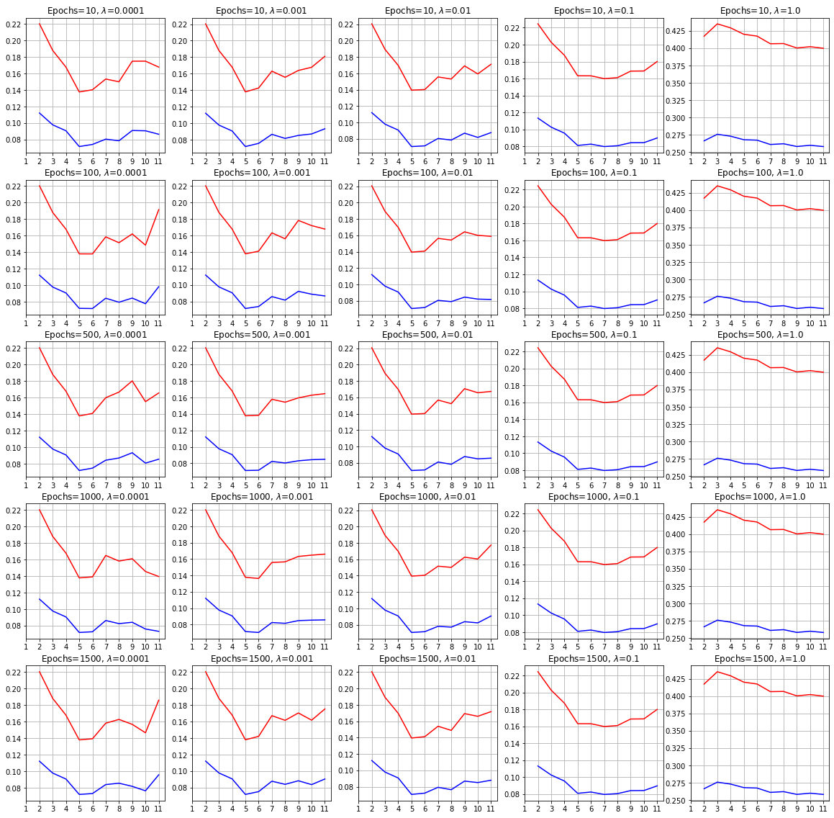   
Fig 12.

Next, I plot the errors for different values of batch size from 1 to 80 (Size of training set) [Fig 13.]

Both batch gradient descent and SGD seem to show good performance, but for few values in the middle, the accuracy decreases. Since there is sharp decline around 35, we take that to be our batch size for final evaluation of degree of polynomial [Fig 14.]

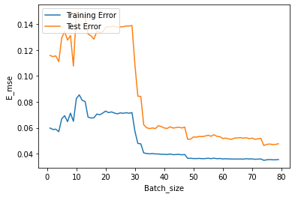  
Fig 13.

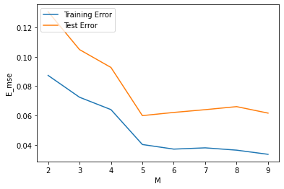  
Fig 14.

Therefore, our initial batch size value of 5 was good for our final estimate of the polynomial which is (For =0.001, epochs = 1500, batch size = 35):

8.97359663 0.59243457 0. 0.23539727**2** 2.35287087**3** 0.51712917 3.44087613**5**

The corresponding plot is:

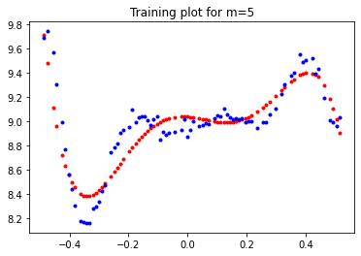  
Fig 15. Red dots are predicted values, blue dots are from dataset

Increasing the number of iterations/epochs did not increase the accuracy by much, and the results were pretty random. In normal sense, we would expect something of a convergence with number of epochs, at least upon the training set. One possible reasoning for this is that my learning rate depends upon batch size index and not the iterations, so overfitting on the data is not as obvious. However, changing that learning rate decreases the model’s performance.

Conclusion

Thus, we conclude that increasing the number of data points gives a much better model prediction. However, for a gradient descent model to work, we would still require much more data points.

In the case of pseudoinverse, models for both n=20 and n=100 were a 9th degree polynomial with close coefficients. But for the stochastic gradient descent, the degree was different and the error was relatively more. Since the degree was different in this case for n=20 and n=100, naturally we saw a change in number of iterations required. Finally, the estimate of the model can be taken as:

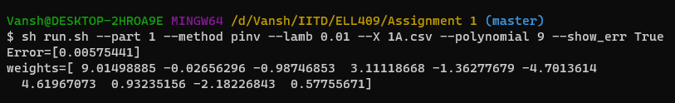

* Noise Estimate:

I have not calculated noise estimate for each of the 4 models, but only for Moore-Penrose pseudoinverse for all 100 data points

How to estimate variance of the noise?

*Var(Y) = E[(Y – E(Y))2]*

*Where E(Y) is our estimate of f(X)*

= 0.006940360733959994

Therefore, variance of the underlying noise is 0.006940360733959994

It should be noted that as the number of data points increase, the variance in noise will also increase as more data points mean more noise to get captured

**Part 1B**

For this part, my focus will be on noise and plots and highest degree of polynomial, as suggested in the assignment pdf. Therefore, I will only be using the Moore-Penrose Pseudoinverse for determination of the underlying polynomial. First, we look at the plot

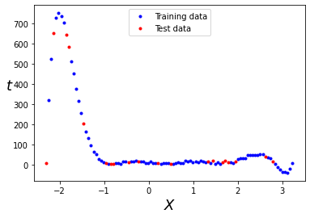  
Fig 16.

Now, we run it through different values of the regularization constant for different values of the degree of polynomial to find further inference. [Fig 17]

Clearly, we see that M=9 is great, but we still need a better plot for . [Fig 18.]

From this we see that for , our model starts to underfit the data. The final polynomial using M=9 and = is:

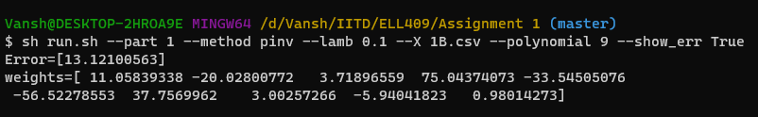

The plot for the same can be seen in Fig 19.

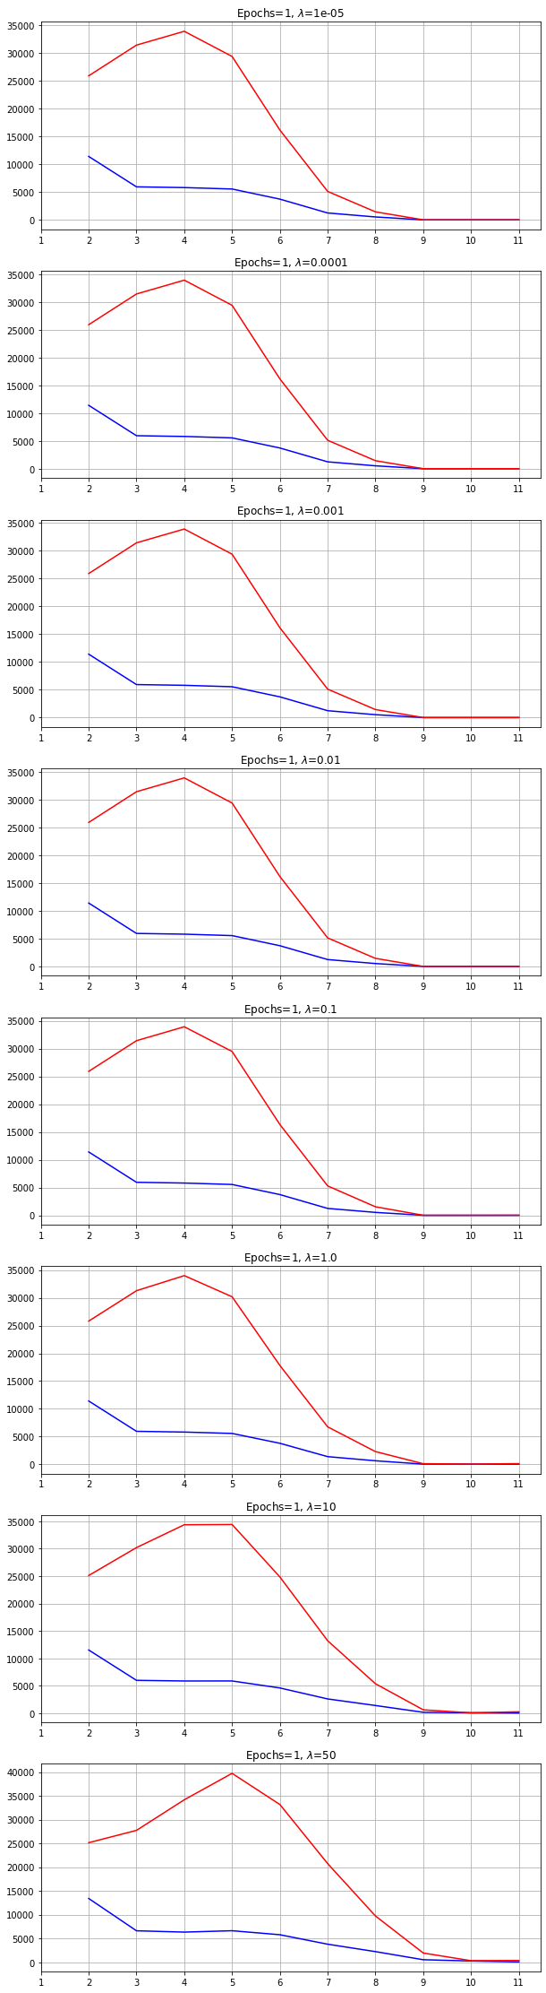   
Fig 17.a Fig 17.b  
y axis depicts the MSE error and x axis shows the different values of m. Blue line is for training dataset while the red line is for testing dataset

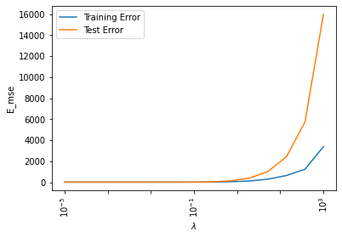  
Fig 18.

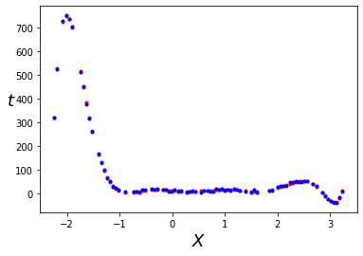   
Fig. 19. Red dots are predicted positions and the blue dots are from the given data

The corresponding plot for test set is:

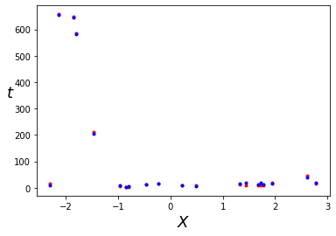

Since the predictions are not far from the point, we can say that the model is not overfitting.

Noise Estimate:

fff

**Part 2**

My first submission to the leaderboard, was well before looking at the data. I simply took the data, added some degrees to all of it and put it up checking the least error. It gave me a decent score, but it was not something fancy that I should discuss here (Even if I am not able to reproduce the results)

The first thing that I did, before having a look at the data, was convert the discrete points of data and month as one single continuous point by min-max normalizing the date and month and adding the two values (Let’s call this new value dime). After that, I tried a bunch of different models with dime and year, and their various exponentials, all of which gave me error to the north of 30. Clearly, I was overcomplicating matters as earlier, my basic submission fetched me good score. (All this is backed by the code that I submitted. This is why I have not provided plots for these, as they can be checked in the python script and is pretty much useless)

Then, I plot the given data on excel, to find this:

There are 3 things that one can infer from this procedure.  
1. My excel skills need a little work  
2. All the dates were 1st date of a month of some year, and will thus have no bearing on the final values. i.e., these can be discarded, thus reducing the given parameters to month and year, and simplifying our model  
3. Lastly, we see that the model is repeating similar trends in a periodic manner and upon further investigation, I found that the model was periodic in terms of year

At this point, I was guessing it was data of avg sales per million or some other value for something sold more in summers, but given the negative values, it could simply be avg temperature on a particular day, which would explain the trend

Nonetheless, I knew what I had to do. Beautify the data by splitting id to month and year, treat them as separate values because their multiplication would make no sense as they seem pretty independent and also, we can apply our prior here that years and months are not correlated.

Finally, due to the lack of bigger dataset, I decided to go with the Moore-Penrose pseudoinverse method of finding my parameters, because my previous analysis showed that it gave better solutions in lesser time for fewer data points (and also because we were only allowed to use linear regression here)

Note: Test set for most part refers to the validation set

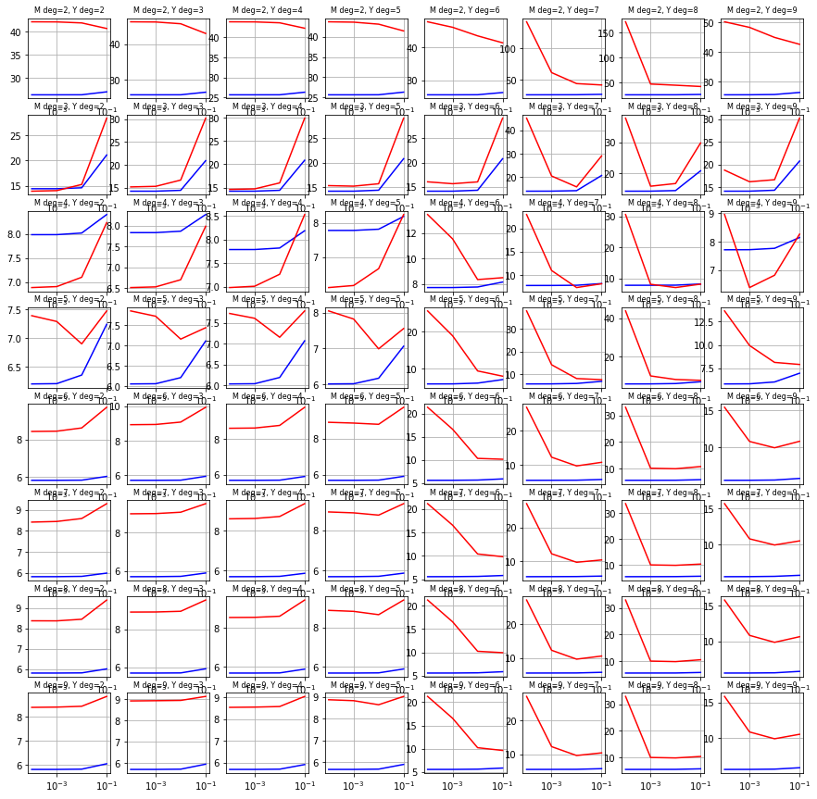

The degree of both month and year columns range from 2 to 9, and is from [0.0001, 0.001, 0.01, 0.1]

We can see that the highest degree of year 8 gives good performance for highest degree of month as 4 and 5. Plotting these 2 across different gives:

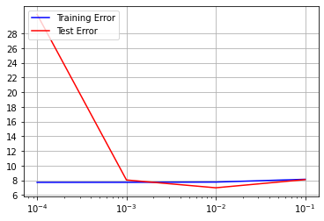 Month degree= 4

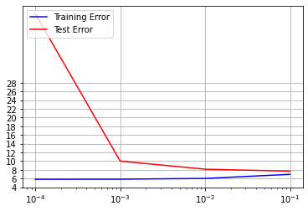 Month degree = 5

Value of can be with month degree = 4. Corresponding values of MSE are:

Training set = 7.765861574815575  
Dev set = 6.988325949280505

At one point, while squaring and cubing and … the columns, I was raising them to some power of 10 to bring to meaningful form (Not become insignificantly small). Upon seeing the final arrays, I realized some of them were blowing up. So, I repeated my experiments without that to get optimal value at = and (Y,M) = (3,7). Corresponding values of MSE are:

Training set: 6.232642519793618  
Dev set: 4.5941934085544665

Corresponding plot for different M and Y:

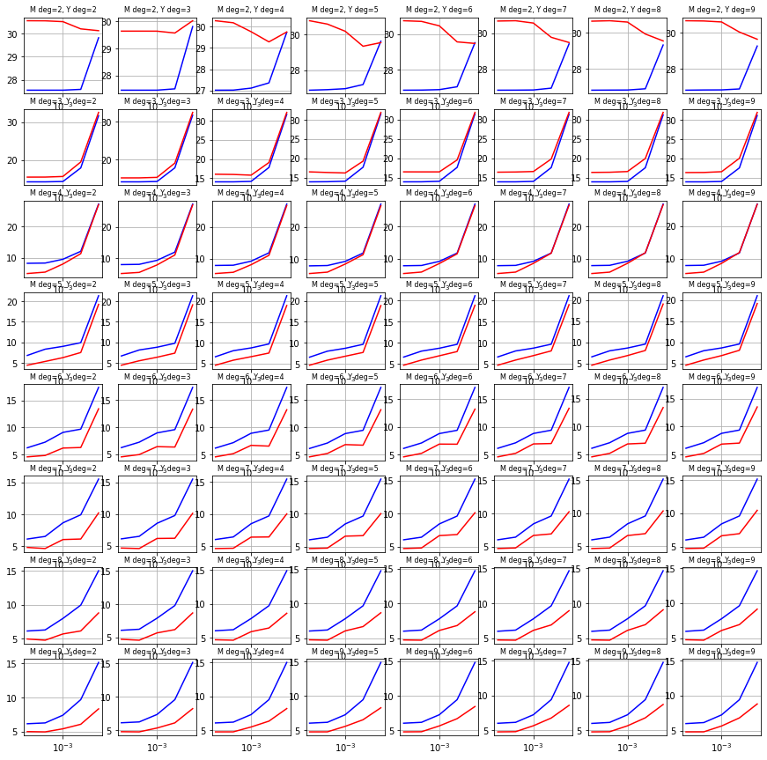

This submission improved the score by a lot and brought me to the range of 6. I was still pretty behind on the leaderboard, but now nothing more could have helped much. I still tried finetuning a bit more but the values I received were far from the values that got me the score of 6.

Note: The values I was submitting were trained only on 90% of the data, and not the entire dataset. My final submission will be trained on the entire dataset

Next, before making a submission, I decided to individually check powers of each parameter (year and month) for my lambda from 2nd set of experiment i.e., 0.0001